**SoftUni OOP Game Contest**

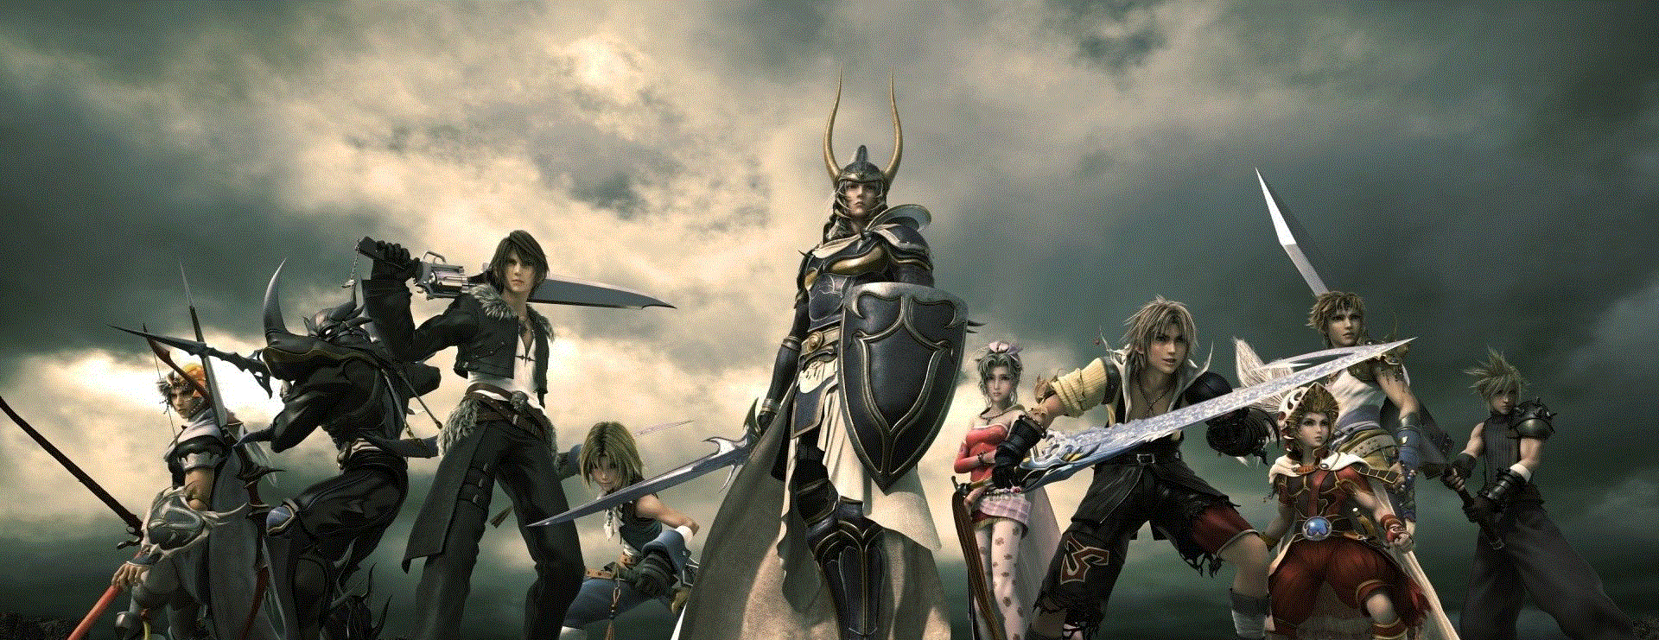

SoftUni is organizing a contest for the best **role playing game** from the OOP teamwork projects. The winning teams will receive a **grand prize**!  
The game should be:

* Properly structured and follow all good OOP practices
* Awesome
* ..Very Awesome

|  |  |  |
| --- | --- | --- |
| Team | Game | Points |
| - | - | - |
| - | - | - |
| - | - | - |

The top 3 teams will receive a **SPECTACULAR** prize:

**A HANDSHAKE FROM NAKOV**